* hamary pas 5 Clusters hen:
Cluster 0: sahib,lode,morning,dance,shows,vulgarity,tv,ka,girls,vulgar
Cluster 1: geo,cancel,najam,hi,blasphemer,set,license,khanzada,legal,army
Cluster 2: sindhi,karachi,terms,province,use,urdu,channel,society,news,words
Cluster 3: amir,liaqat,biol,dr,program,hate,hussein,tv,spreading,religious
Cluster 4: channel,news,tv,indian,pakistan,action,stop,islam,petra,ad
duplicate values within Clusters Qty.: 4

news [2, 4] 2nd and 4rht cluster
channel [2, 4] 2nd and 4rth cluster
tv [0, 3, 4]

total Observations: 13405

unique Complaints: 8955
duplicaates: 4450

unique Complaints ID: 9459
duplicates: 3946

Monthly Data:

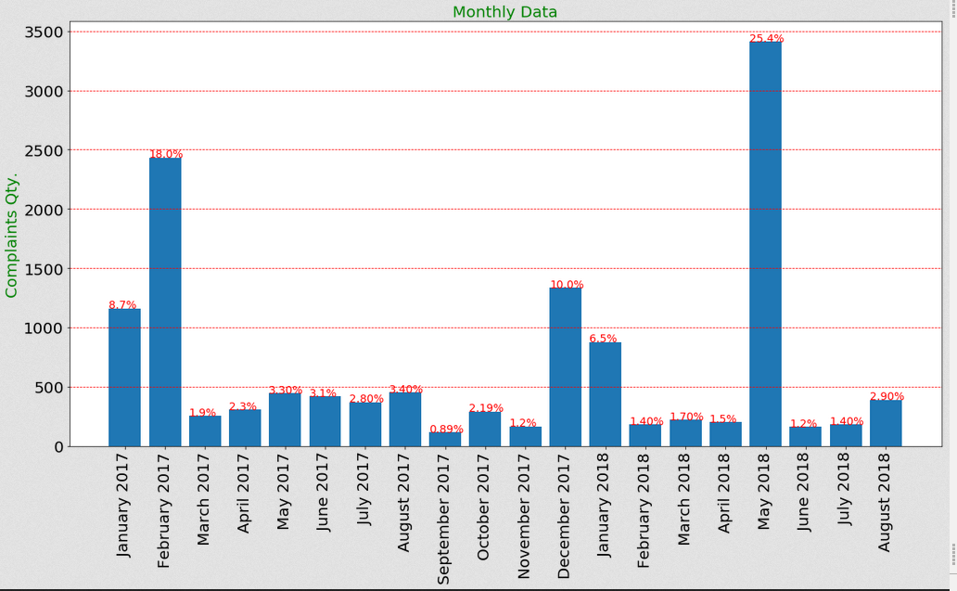

wo Channels jin ki total Complains 100 sy zyada hen (ratio total me sy h):
Note: 100 sy oper waly channels ki total complains 12190 hen, (12190 / 13405 = ~91%)

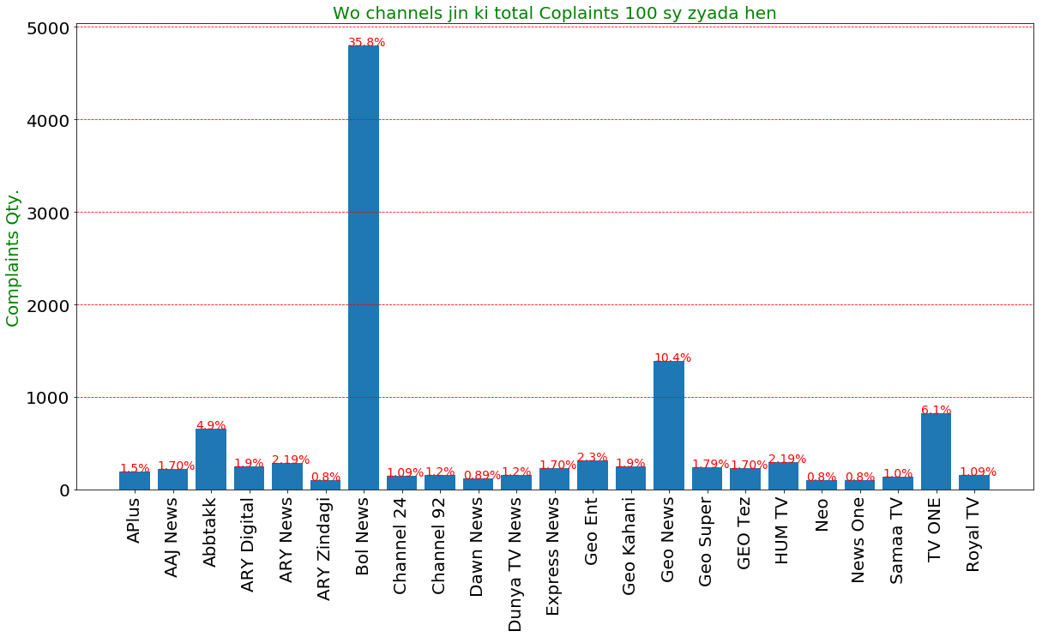

Bol News ki bohot zyada complains hen, 35.8 % from total Complains, so ham Bol News ka monthly chart banaty hen:

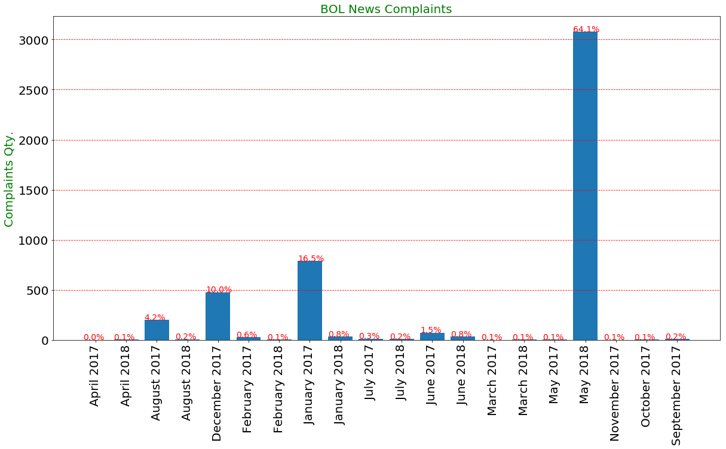

yahan May 2018 bohot extreme value h,
Note: agar May 2018 ki Complaints ko hata kar dekha jay to BOL News ka ratio total Complaints me sy 0.17 h

Complaints for Bol News in May 2018:
3077

unique Complaint:
3002

duplicate complaints:
75

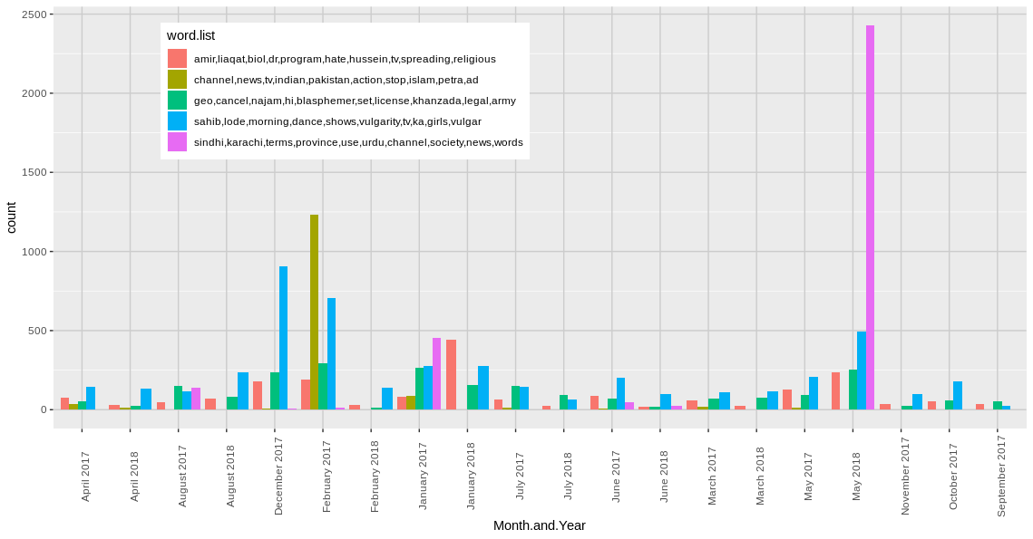

is plot sy ye pata chal k may 2018 ki wajah darasal <sindhi, karachi….> wala group h,
ab is group k bary me kuch statistics:

ye group
<sindhi,karachi,terms,province,use,urdu,channel,society,news,words>
is group ki is month me 2426 Complains hen. (~71% of this month)
is data me ye group 3119 times aaya h (3119 / 2426 = ~78%)

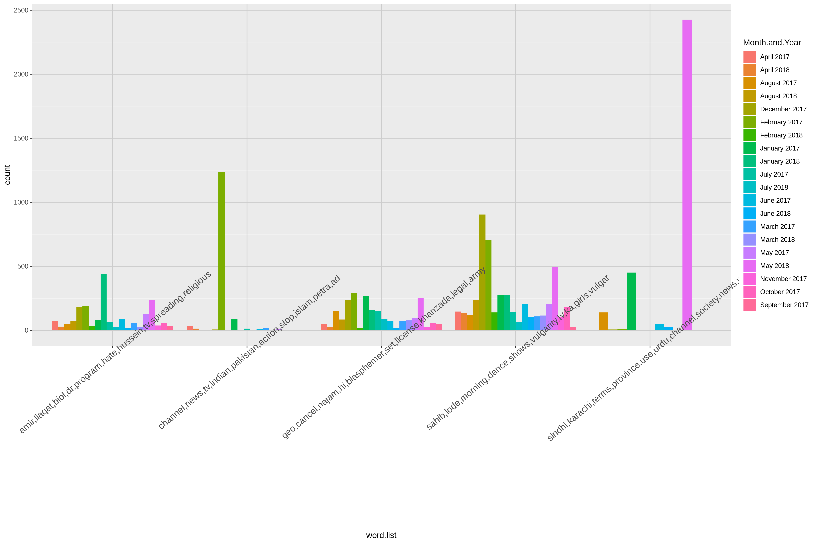
cd Dropbox/LFD/LFD\ NLP\(clustring\)\ PEMRA\ COMPLSINTS/
shotwell R_plot_2.png

yahan 2 extreme values hen:

1- May 2018:
- Complains Qty.: 3410
- <sindhi,karachi,terms,province,use,urdu,channel,society,news,words>
is group ki is month me 2426 Complains hen. (~71% of this month)
is data me ye group 3119 times aaya h (3119 / 2426 = ~78%)
2- February 2017:
Complains Qty.: 2433
<channel,news,tv,indian,pakistan,action,stop,islam,petra,ad>
is group ki is month me 1235 Complains hen. (~51% of this month)
is data me ye group total 1455 times aaya h (1235 / 1455 = ~85 %)
------------------------------------------------------------------------------------------------------------------------

five samples from each cluster

group: 1
(amir,liaqat,biol,dr,program,hate,hussein,tv,spreading,religious)

Complain 1: there is a morning show hosted by sahib lodhihe latterly has no other topic except dancing with girls and celebrate someones wedding with lot of doom dharakabut it is now crossing the limit he invites teen age school college girls and they perform on cheap and valour Indian item songs all the audience including host enjoying their dances and taking full time mazayi mean what is he promoting its not our culture not our values for god sake ban sahib lode and his morning show kindly take action all these type of Indian culture promoting showsplz Pl Pl take a strong action

Complain 2: they operate some unwanted political show and talk about division of provision and abuse the army so kindly take action as soon as possible we love our country and army

Complain 3: sahib lode morning show dance of underage and teenage girls we are officially an Islam state not a liberal or secular state we need programmes that will build character of future generations according to Islam

Complain 4: block amir liquid shows

Complain 5: dear sir can you not have to seen show of sail lode in eid and do dance in eid show and it very shame less dear sir can you not have to seen show of sail lode in eid and do dance in eid show and it very shame less

____________________________________________________________________________________________________
group: 2
(channel,news,tv,indian,pakistan,action,stop,islam,petra,ad)

Complain 1: ban Geo they are creating violation and also supporting blasphemer bloggers cancel its license and take legal action against najam set hi and shazaib khanzada ban Geo cancel its license

Complain 2: Geo supported blasphemers ban Geo

Complain 3: ban Geo immediately cancel its license take legal action against najam set hi shahzaib khanzada and Geo owner ban Geo immediately cancel its licence

Complain 4: owners of Geo supports the enemies of Islam and Pakistan take immediate action against Geo

Complain 5: we are disturbed by Geo and its so called anchors you are institute of Pakistan not Geo Park army is always insulting by Geo y stop negative propaganda that Geo creating against 295c Islam Pakistan is everything for us ban Geo they supporting blasphemer bloggers we have proof against them ban Geo and cancel its licence also ban najam set hi shahzaib khanzada

____________________________________________________________________________________________________
group: 3
(geo,cancel,najam,hi,blasphemer,set,license,khanzada,legal,army)

Complain 1: i would like to bring this in your notice all the channel are so openly discussing sunny Leon she being an adult actress is not a good example to be discussed at all by discussing her is part of normalisation of an adult actress in our society as or social and religious values both do not allow us to discuses such things an order should be issued to strictly discussing such personalities in specific and also in general if pointing out one name is not appropriate kindly publish a list or just simply mention not discuss people of such background

Complain 2: please watch below mentioned short video which is self explanatory Petra should arrange a sensor board for dramas screening should black list these dramas actors actresses

Complain 3: dear pta team all the Urdu media news channel are calling Sindhi and Karachi separate entities which hurts our feelings we record our protest before you please take an emergency notice against all these biased Urdu media news channel please issue notification regarding our complaint and make Urdu media strictly obedient of pta rules and constitution of Pakistan

Complain 4: hi my name is Layla and i wanted to file a report of a host Elena lode harpoon is a wanted criminal and the police is in search for her as there is a filed fir against her her husband mother brother sister and brother in law they are a family of robbers thief's and criminals she has attacked a house in Lahore stole and rs along with pair of gold bangles which cost almost rs she brought cars full of armed men to harm the family if they came in their way they had guns and knives if you wish to see the fir contact me through my email and i will provide you with a copy of the fir you should ban her show as she is throwing threats through her journalism she doesn't deserve fame but instead a lot of shame fire her and tell the police if she comes in contact with you as she should be in jail

Complain 5: i would like to bring this in your notice all the channel are so openly discussing sunny Leon she being an adult actress is not a good example to be discussed at all by discussing her is part of normalisation of an adult actress in our society as or social and religious values both do not allow us to discuses such things an order should be issued to strictly discussing such personalities in specific and also in general if pointing out one name is not appropriate kindly publish a list or just simply mention not discuss people of such background

____________________________________________________________________________________________________
group: 4
(sahib,lode,morning,dance,shows,vulgarity,tv,ka,girls,vulgar)

Complain 1: as it is declared by Petra that no Indian drama will be shown on any TV channel Urdu recently started an Indian drama negating all the rules and restrictions made by Petra regarding Indian content i as a media student strongly condemn this act of Urdu and seeking a notice and an action against this channel issue Urdu a notice to immediately stop this drama

Complain 2: the way we communicate is evolving as we enter an increasingly more digital world communication through social media or electronic media has become more important then ever but some media channel are evolving in such a blame games and showing false news in order to spreading hate in people on sentimental issues like hat me nanobot biol news is one of them take a serious action against such nonsense and false news about jib ran nadir or something else this kind of program and channel should be ban permanently

Complain 3: this TV black mail institutes and persons this should be blocked and heavily fined as they recently aired fake show against combats a top university very strict action should be taken against it

Complain 4: falsely ac cussing individuals of serious crimes without evidence channel should be fined and ban from airing such material

Complain 5: the airy news propagated wrong news about mna mahmood khan achakzai while he was in Pakistan the said TV channel reported him as if hes in India and has met with the Israeli pm and Indian pm the defamation to the personality of pashtun leader and elected mna mahmood khan achakzai has to be addressed and the said TV should be off from on airing until it goes for an apology for the wrong propaganda against mahmood khan achakzai

____________________________________________________________________________________________________
group: 5
(sindhi,karachi,terms,province,use,urdu,channel,society,news,words)

Complain 1: Mr Petra chairman are you Muslim first of all you need confirm itniw ramzan is going on did seen most probably nude and where is implementation on time Azana on all chanals did you notice how much amir leyaqt strait religious extremism programs on TV you should ashamed if getting salary under oath pf protection of Pakistan ideology ban these kind of programs and important all order of Islam cultural nag also high court of isb

Complain 2: dreamier liaqat should be ban he is doing propaganda ban Mr amir liaqat show

Complain 3: amir liaqat is fuelling sectarianism firqa wariest he must be ban from religious TV programs he is a complete rangbaz using religion for his personal gains by moulding facts

Complain 4: hate speech targeting a tribe ban amir liaqat

Complain 5: the show hosted on biol news by amir liaqat is full of lies and degrading social values and humiliation for different communities the show comprises of news which are not fact but on aired just to create chaos rumours and disrespect amir liaqat has consistently targeted different communities in his previous programs on different channel amir liaqat must be ban on electronic media as his shows are full of lies against our social values and disrespecting different communities and individuals in Pakistan he is a threat to our national integrity causing disrespect for different ethnic communities so he must be ban on electronic media

